Nhóm 12

**HOẠT ĐỘNG NHÓM THỰC HIỆN**

1. **Bảng phân công công việc**

| MaSV | Họ tên | Mô tả công việc được giao | Ghi chú |
| --- | --- | --- | --- |
| 2015722 | Lê Anh Khôi | Nội dung 2 câu 3 | Nhóm trưởng |
| 2011353 | Trịnh Ngọc Hoàng Anh |  | Thư ký |
| 2015597 | Đoàn Quang Huy |  |  |
| 2011438 | Hoàng Ngọc Minh Thắng | Nội dung 2 câu 1 |  |

1. **Nội dung thực hiện**

**Nội dung 1:**

**Nội dung 2: Chạy bằng tay các bước tìm đường đi ngắn nhất từ 1 đỉnh đến các đỉnh còn lại dùng thuật toán Dijkstra.**

**1) Tìm bậc của các đỉnh và tìm đường đi ngắn nhất từ x1 tới các đỉnh còn lại (vô hướng)**

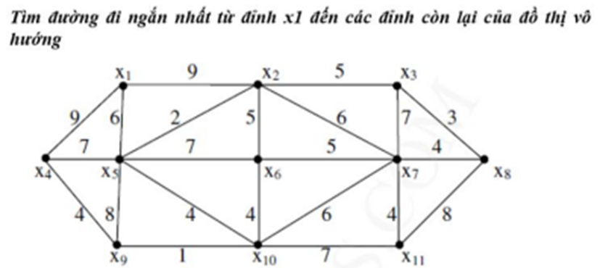

| **Deg(x1) = 3**  **Deg(x2) = 5**  **Deg(x3) = 3**  **Deg(x4) = 3**  **Deg(x5) = 6**  **Deg(x6) = 4** | **Deg(x7) = 6**  **Deg(x8) = 3**  **Deg(x9) = 3**  **Deg(x10) = 5**  **Deg(x11) = 3** |
| --- | --- |

| **x1** | **x4** | **x5** | **x9** | **x2** | **x6** | **x10** | **x3** | **x7** | **x11** | **x8** |
| --- | --- | --- | --- | --- | --- | --- | --- | --- | --- | --- |
| **0\*** | **(∞, -)** | **(∞, -)** | **(∞, -)** | **(∞, -)** | **(∞, -)** | **(∞, -)** | **(∞, -)** | **(∞, -)** | **(∞, -)** | **(∞, -)** |
| **-** | **(9, x1)** | **(6, x1)\*** | **(∞, -)** | **(9, x1)** | **(∞, -)** | **(∞, -)** | **(∞, -)** | **(∞, -)** | **(∞, -)** | **(∞, -)** |
| **-** | **(9, x1)** | **-** | **(14, x5)** | **(8, x5)\*** | **(13, x5)** | **(10, x5)** | **(∞, -)** | **(∞, -)** | **(∞, -)** | **(∞, -)** |
| **-** | **(9, x1)\*** | **-** | **(14, x5)** | **-** | **(13, x5)** | **(10, x5)** | **(13, x2)** | **(14, x2)** | **(∞, -)** | **(∞, -)** |
| **-** | **-** | **-** | **(13, x4)** | **-** | **(13, x5)** | **(10, x5)\*** | **(13, x2)** | **(14, x2)** | **(∞, -)** | **(∞, -)** |
| **-** | **-** | **-** | **(11, x10)\*** | **-** | **(13, x5)** | **-** | **(13, x2)** | **(14, x2)** | **(17, x10)** | **(∞, -)** |
| **-** | **-** | **-** | **-** | **-** | **(13, x5)\*** | **-** | **(13, x2)** | **(14, x2)** | **(17, x10)** | **(∞, -)** |
| **-** | **-** | **-** | **-** | **-** | **-** | **-** | **(13, x2)\*** | **(14, x2)** | **(17, x10)** | **(∞, -)** |
| **-** | **-** | **-** | **-** | **-** | **-** | **-** | **-** | **(14, x2)\*** | **(17, x10)** | **(16, x3)** |
| **-** | **-** | **-** | **-** | **-** | **-** | **-** | **-** | **-** | **(17, x10)** | **(16, x3)\*** |
| **-** | **-** | **-** | **-** | **-** | **-** | **-** | **-** | **-** | **(17, x10)\*** | **-** |

**Đường đi ngắn nhất từ x1 tới các đỉnh**

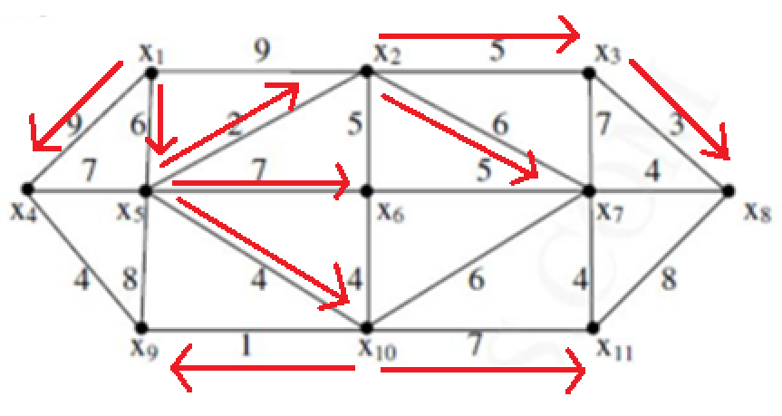

**2)**

**Câu 1:**

**Vào**

**Deg(A) = 0**

**Deg(B) = 3**

**Deg(C) = 2**

**Deg(D) = 3**

**Deg(E) = 2**

**Deg(F) = 2**

**Deg(G) = 2**

**Deg(H) = 1**

**Deg(I) = 2**

**Deg(K) = 3**

**Deg(M) = 2**

**Ra**

**Deg+(A) = 3**

**Deg+(B) = 2**

**Deg+(C) = 3**

**Deg+(D) = 0**

**Deg+(E) = 2**

**Deg+(F) = 2**

**Deg+(G) = 2**

**Deg+(H) = 2**

**Deg+(I) = 3**

**Deg+(K) = 2**

**Deg+(M) = 1**

**Câu 2:**

| **A** | **B** | **C** | **D** | **E** | **F** | **G** | **H** | **I** | **K** | **M** |
| --- | --- | --- | --- | --- | --- | --- | --- | --- | --- | --- |
| **0\*** | **()** | **()** | **()** | **()** | **()** | **()** | **()** | **()** | **()** | **()** |
| **-** | **(7, A)** | **()** | **()** | **(4, A)** | **()** | **()** | **(1,A)\*** | **()** | **()** | **()** |
| **-** | **(7, A)** | **()** | **()** | **(3, H)\*** | **()** | **()** | **-** | **(3, H)** | **()** | **()** |
| **-** | **(6, E)** | **()** | **()** | **-** | **()** | **()** | **-** | **(3, H)\*** | **()** | **()** |
| **-** | **(6, E)\*** | **()** | **()** | **-** | **(7, I)** | **()** | **-** | **-** | **(12, I)** | **()** |
| **-** | **-** | **(9, B)** | **()** | **-** | **(7, I)\*** | **()** | **-** | **-** | **(12, I)** | **()** |
| **-** | **-** | **(9, B)\*** | **()** | **-** | **-** | **()** | **-** | **-** | **12, I)** | **()** |
| **-** | **-** | **-** | **(17, C)** | **-** | **-** | **(15, C)** | **-** | **-** | **(11, C)\*** | **()** |
| **-** | **-** | **-** | **(17, C)** | **-** | **-** | **(15, C)\*** | **-** | **-** | **-** | **()** |
| **-** | **-** | **-** | **(17,C)\*** | **-** | **-** | **-** | **-** | **-** | **-** | **(19, G)** |
| **-** | **-** | **-** | **-** | **-** | **-** | **-** | **-** | **-** | **-** | **(19, G)** |

**Đường đi ngắn nhất của A tới các đỉnh**

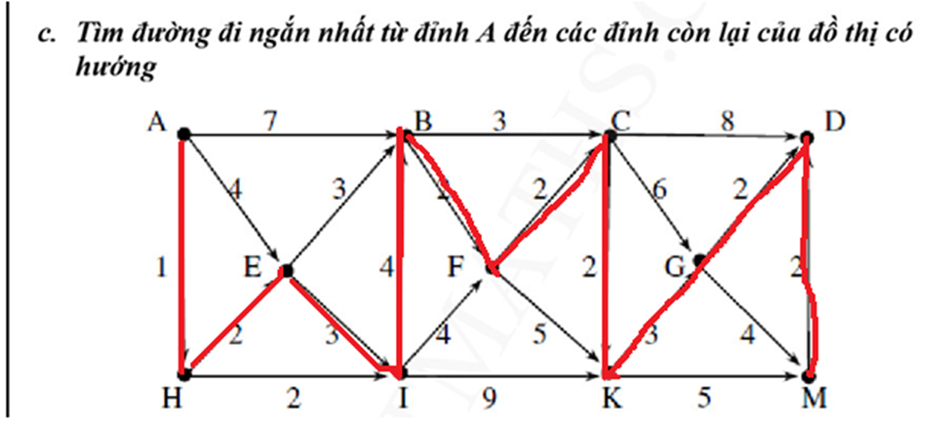

**3)**

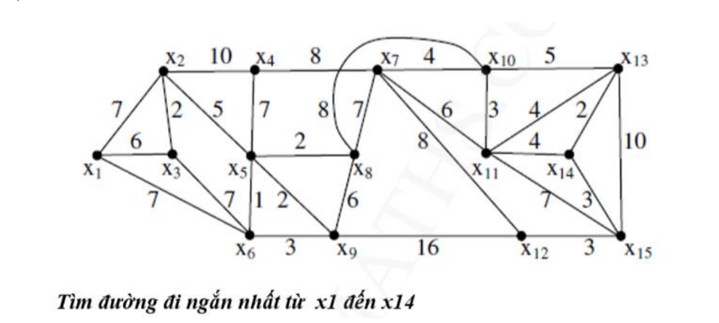

**Vào**

**Deg(x1) = 0**

**Deg(x2) = 2**

**Deg(x3) = 3**

**Deg(x4) = 3**

**Deg(x5) = 5**

**Deg(x6) = 4**

**Deg(x7) = 5**

**Deg(x8) = 4**

**Deg(x9) = 4**

**Deg(x10) = 4**

**Deg(x11) = 5**

**Deg(x12) = 3**

**Deg(x13) = 4**

**Deg(x14) = 3**

**Deg(x15) = 4**

**Ra**

**Deg(x1) = 3**

**Deg(x2) = 2**

**Deg(x3) = 3**

**Deg(x4) = 3**

**Deg(x5) = 5**

**Deg(x6) = 4**

**Deg(x7) = 5**

**Deg(x8) = 4**

**Deg(x9) = 4**

**Deg(x10) = 4**

**Deg(x11) = 5**

**Deg(x12) = 3**

**Deg(x13) = 4**

**Deg(x14) = 3**

**Deg(x15) = 4**

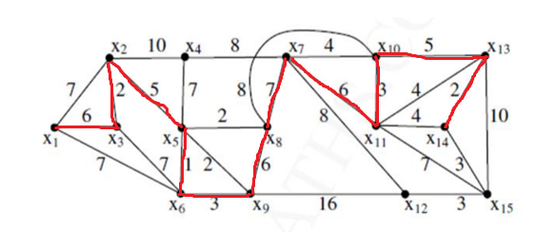

| **X1** | **X2** | **X3** | **X4** | **X5** | **X6** | **X7** | **X8** | **X9** | **X10** | **X11** | **X12** | **X13** | **X14** | **X15** |
| --- | --- | --- | --- | --- | --- | --- | --- | --- | --- | --- | --- | --- | --- | --- |
| **0\*** | **(∞, )** | **(∞, )** | **(∞, )** | **(∞, )** | **(∞, )** | **(∞, )** | **(∞, )** | **(∞, )** | **(∞, )** | **(∞, )** | **(∞, )** | **(∞, )** | **(∞, )** | **(∞, )** |
| **-** | **(7,x1)** | **(6,x1)** | **(∞, )** | **(∞, )** | **(7,x1)** | **(∞, )** | **(∞, )** | **(∞, )** | **(∞, )** | **(∞, )** | **(∞, )** | **(∞, )** | **(∞, )** | **(∞, )** |
| **-** | **(8,x3)** | **-** | **(∞, )** | **(∞, )** | **(13,x3)** | **(∞, )** | **(∞, )** | **(∞, )** | **(∞, )** | **(∞, )** | **(∞, )** | **(∞, )** | **(∞, )** | **(∞, )** |
| **-** | **-** | **-** | **(18,x2)** | **(13,x2)** | **(∞, )** | **(∞, )** | **(∞, )** | **(∞, )** | **(∞, )** | **(∞, )** | **(∞, )** | **(∞, )** | **(∞, )** | **(∞, )** |
| **-** | **-** | **-** | **(20,x5)** | **-** | **(14,x5)** | **(∞, )** | **(15,x5)** | **(15,x5)** | **(∞, )** | **(∞, )** | **(∞, )** | **(∞, )** | **(∞, )** | **(∞, )** |
| **-** | **-** | **-** | **(∞, )** | **-** | **-** | **(∞, )** | **(∞, )** | **(17,x6)** | **(∞, )** | **(∞, )** | **(∞, )** | **(∞, )** | **(∞, )** | **(∞, )** |
| **-** | **-** | **-** | **(∞, )** | **-** | **-** | **(∞, )** | **(23,x9)** | **-** | **(∞, )** | **(∞, )** | **(33,x9)** | **(∞, )** | **(∞, )** | **(∞, )** |
| **-** | **-** | **-** | **(∞, )** | **-** | **-** | **(30,x8)** | **-** | **-** | **(31,x8)** | **(∞, )** | **(∞, )** | **(∞, )** | **(∞, )** | **(∞, )** |
|  | **-** | **-** | **(38,x7)** | **-** | **-** | **-** | **-** | **-** | **(∞, )** | **(36,x7)** | **(38,x7)** | **(∞, )** | **(∞, )** | **(∞, )** |
| **-** | **-** | **-** | **-** | **-** | **-** | **-** | **-** | **-** | **(39,x11)** | **-** | **-** | **(40,x11)** | **(40,x11)** | **(42,x11)** |
| **-** | **-** | **-** | **-** | **-** | **-** | **-** | **-** | **-** | **-** | **-** | **-** | **(44,x10)** | **(∞, )** | **(∞, )** |
| **-** | **-** | **-** | **-** | **-** | **-** | **-** | **-** | **-** | **-** | **-** | **-** | **-** | **(46,x13)** | **(54,x13)** |
| **-** | **-** | **-** | **-** | **-** | **-** | **-** | **-** | **-** | **-** | **-** | **-** | **-** | **-** | **(49,x14)** |